United Presbyterian Church
Pottsville, Pennsylvania
214 Mahantongo St
Email mail@unitedpresbyterian.com
Phone 570-622-1760

Virtual Worship Service instructions:

Before we begin you should know these two words:
BROWSER-the place on your computer that navigates the World Wide Web and
INTERNET-the global computer network that provides you access to the World Wide Web. Common services include: Comcast, Gmail, AOL, Verizon, Yahoo)

Let’s get started: Do you have internet? Do you have a computer? Do you have a cell phone, tablet, or Ipad? If you have access to ANY of these tools you will find instructions below so that you can learn how to connect to your church family and friends.

If you only have access to a landline telephone, please go directly to the section marked: PHONE USERS.
Our Sunday “virtual” (not in person) worship services are being held on “ZOOM” and streamed on “FACEBOOK LIVE” starting 4/19/20. What does this mean to you? We want you to join us by following the steps below:

If you have an apple device or Mac, jump to “INSTRUCTIONS FOR APPLE DEVICES”
1
ALL OTHER COMPUTER USERS:
Do you know where your internet browser is on your computer? If you use Google Chrome it looks like this: (The circled item below)
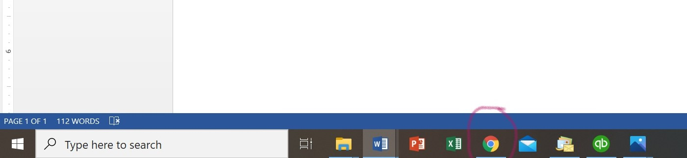

If you don’t have an icon the bottom of your computer for your internet browser, you want to click on the Windows key that looks something like this:
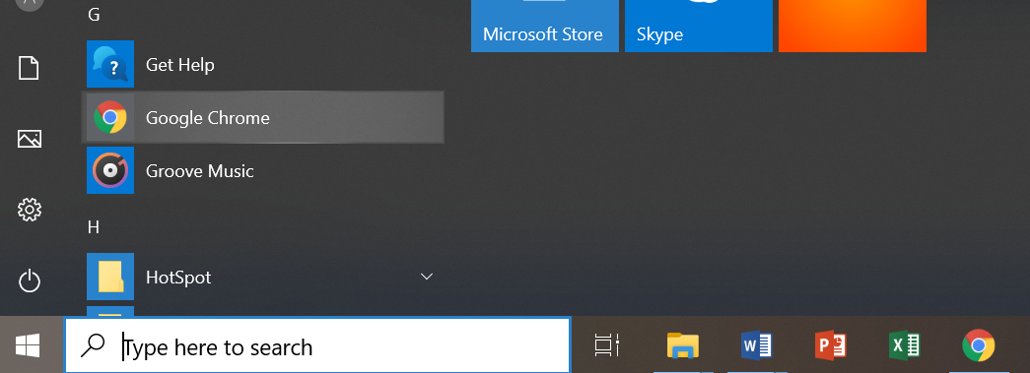
Windows Key

Once you have clicked on the windows key it will bring up a list of your programs.
You will need to scroll or page down through your programs until you highlight what you will use to get on the internet. It may be google, safari, internet, foxfire, or Microsoft Edge (new computers).
Once you have item highlighted (like above), double click to open browser.
Now your browser is open and looks something like this: 1
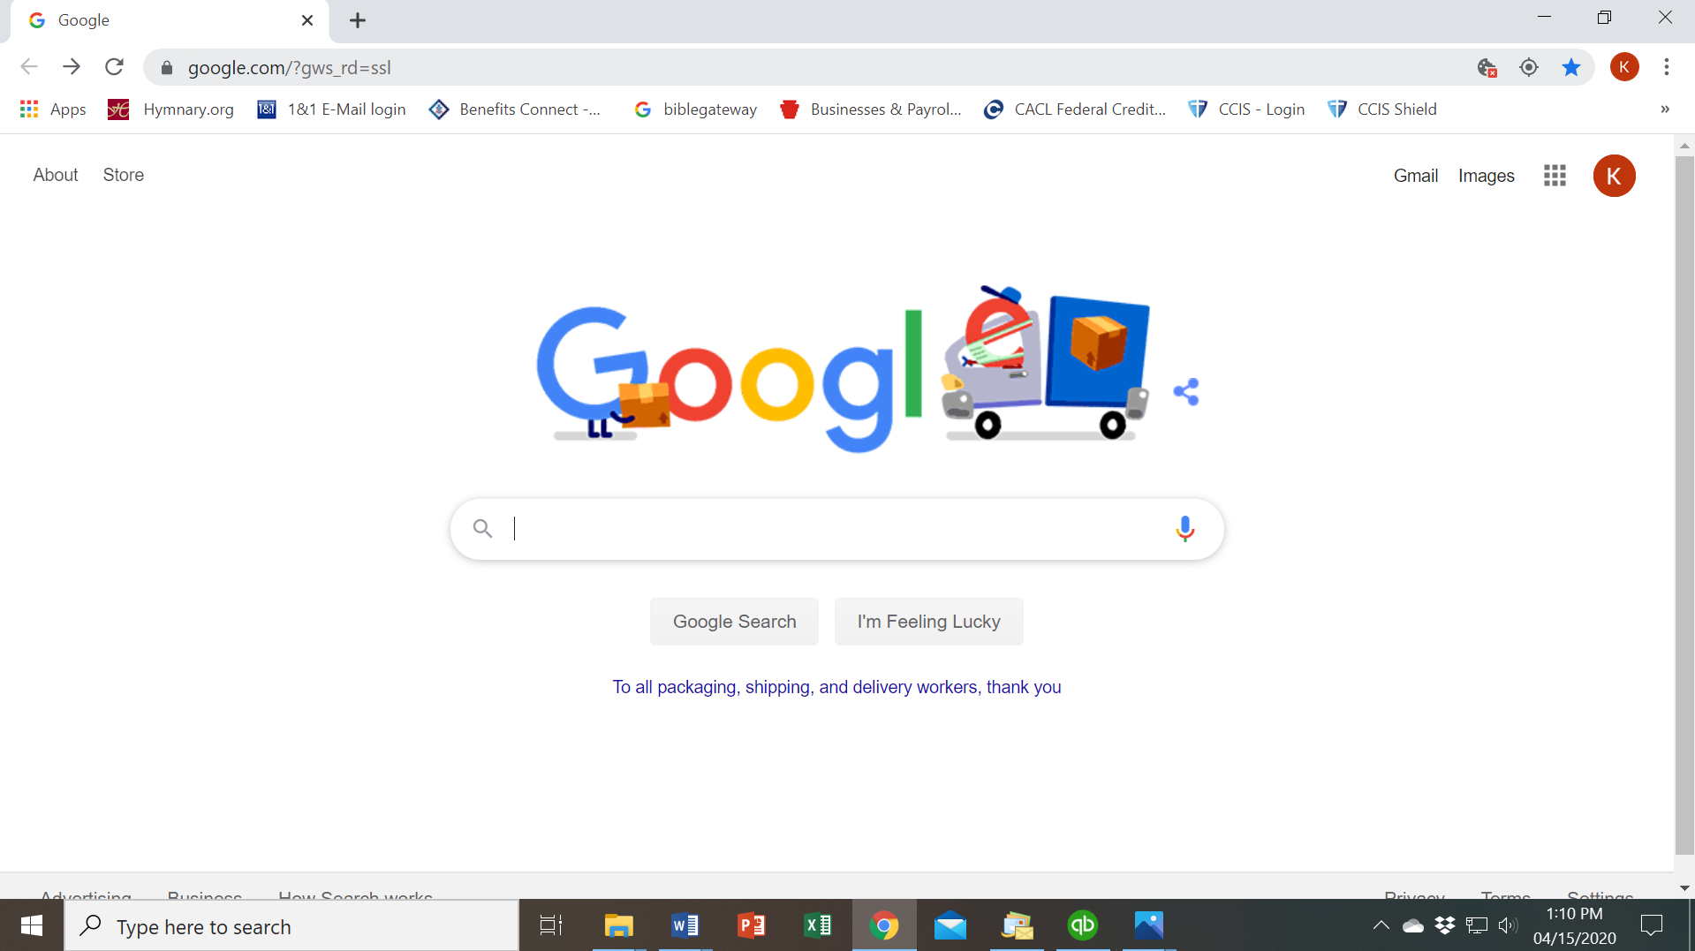 (If you aren’t using Google, it should look like your homepage on the internet)

Now you are ready to go to Zoom.
Type in your web browser Zoom.us (like shown below) and click enter. This will bring you to Zoom.
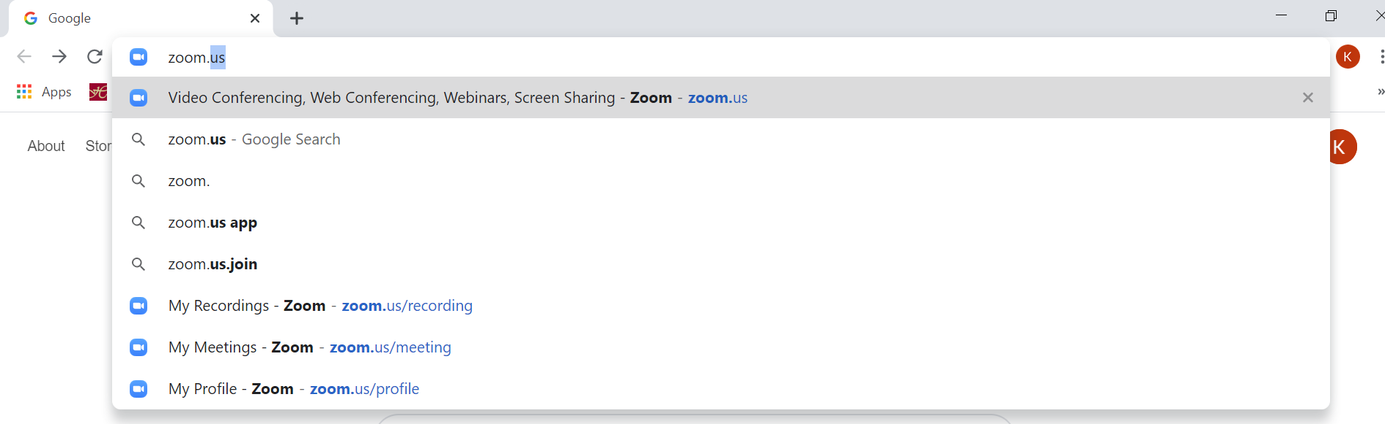
You want the option to join a meeting: Meeting ID will always be: 568-073-9198

Zoom makes you download the program the first time you use it. Once you click Download it will look like the picture below:

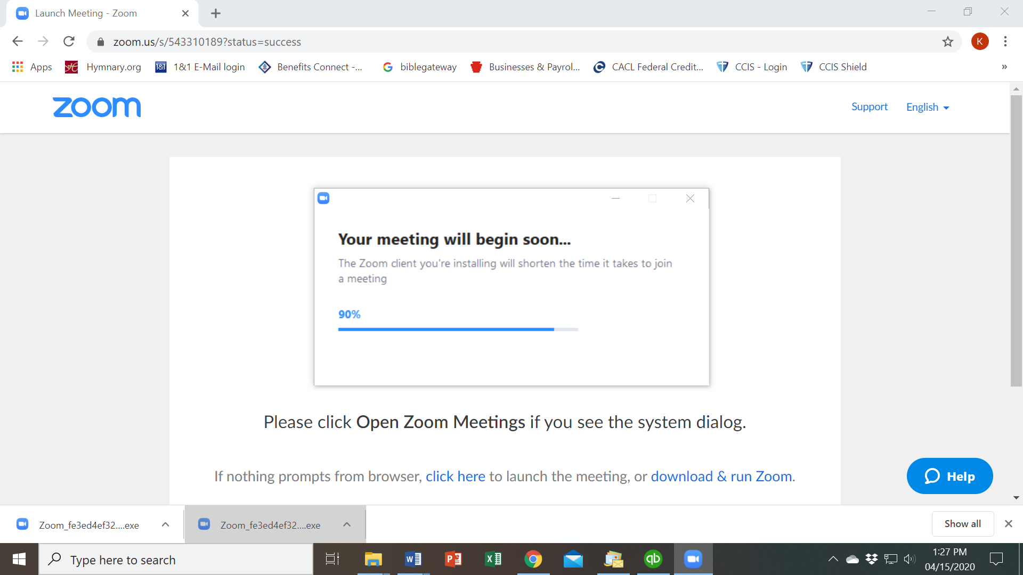
As soon as the program is done downloading it will bring you to the meeting:

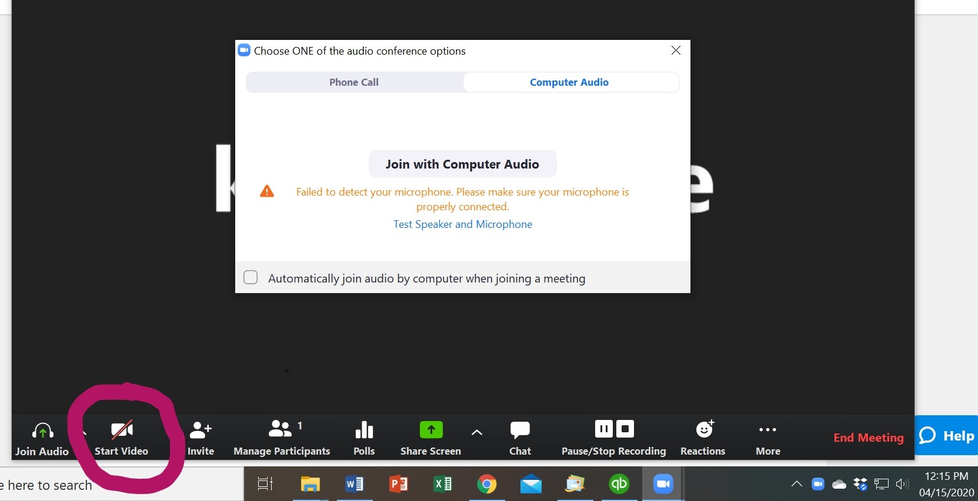
2
At this point if you have a microphone installed on your computer it will ask you to Join with Computer Audio-this allows you to talk in the meeting.
Please click the box shown above (Automatically join audio by computer when joining a meeting)
You won’t have to answer this the next time you join us. This keeps your audio signed in.

If you have a webcam installed on your computer you will click on ‘Start Video’ at bottom of your screen (as seen above) This allows everyone to see your smiling faces!
(My computer does not have this option that is why it has a slash through it)

Now you are ready for Worship Service!

INSTRUCTIONS FOR APPLE DEVICES:
Step 1:
Please open your device and go to App Store. The icon looks like this!

Step 2: Type in Search option: zoom.us
The app should look like below...

Step 3: Click the download cloud to download Zoom

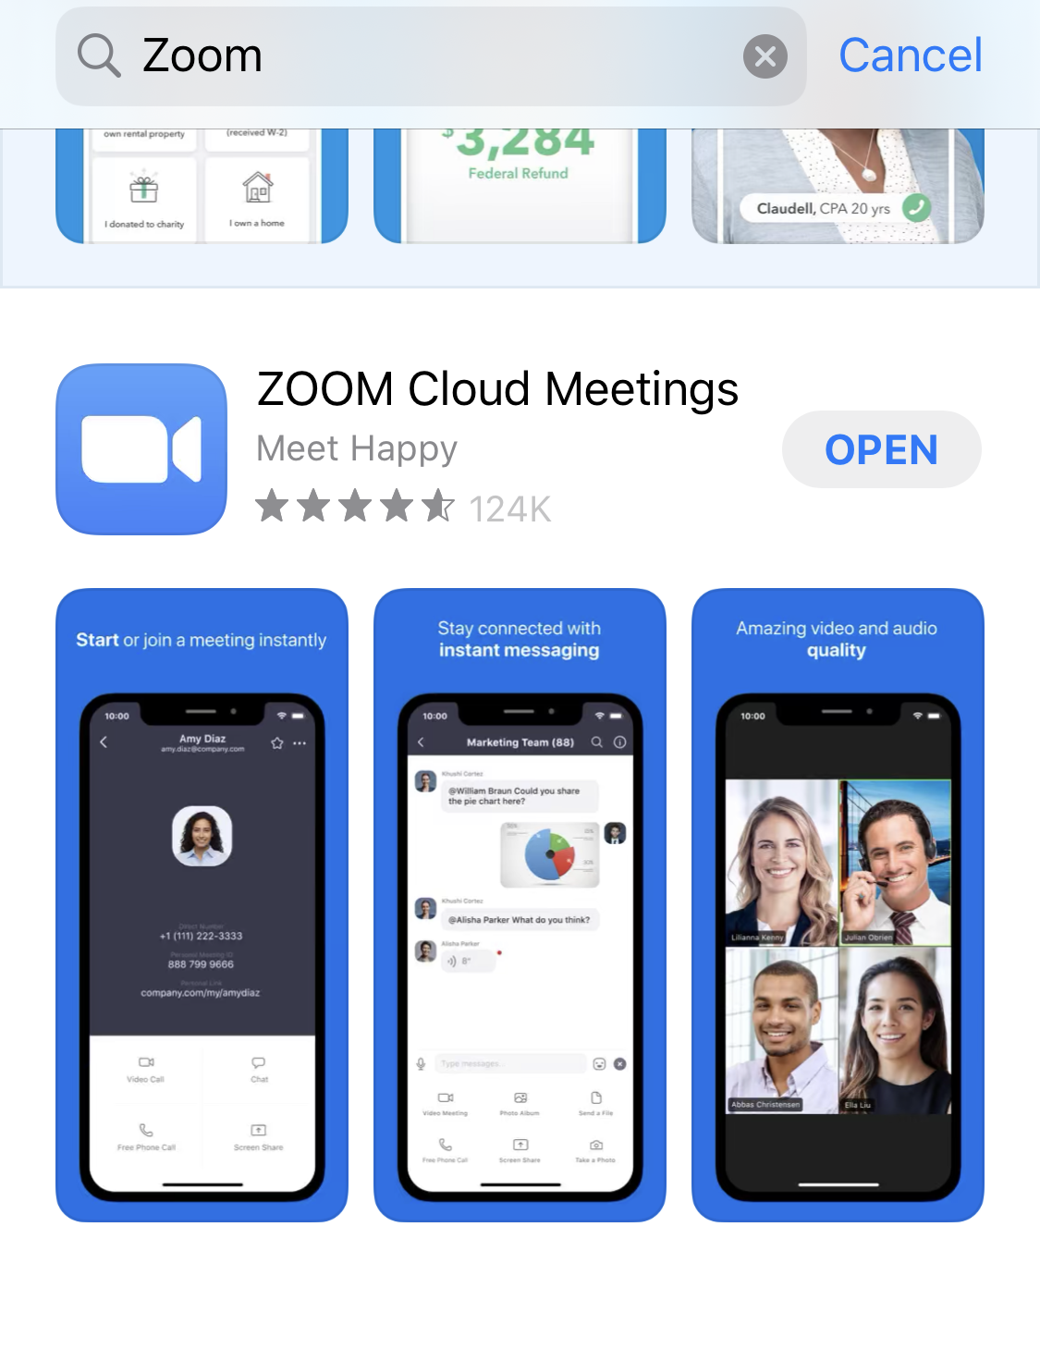(Where the picture here shows open it will show the download cloud for new users)
Step 4: Open the app…

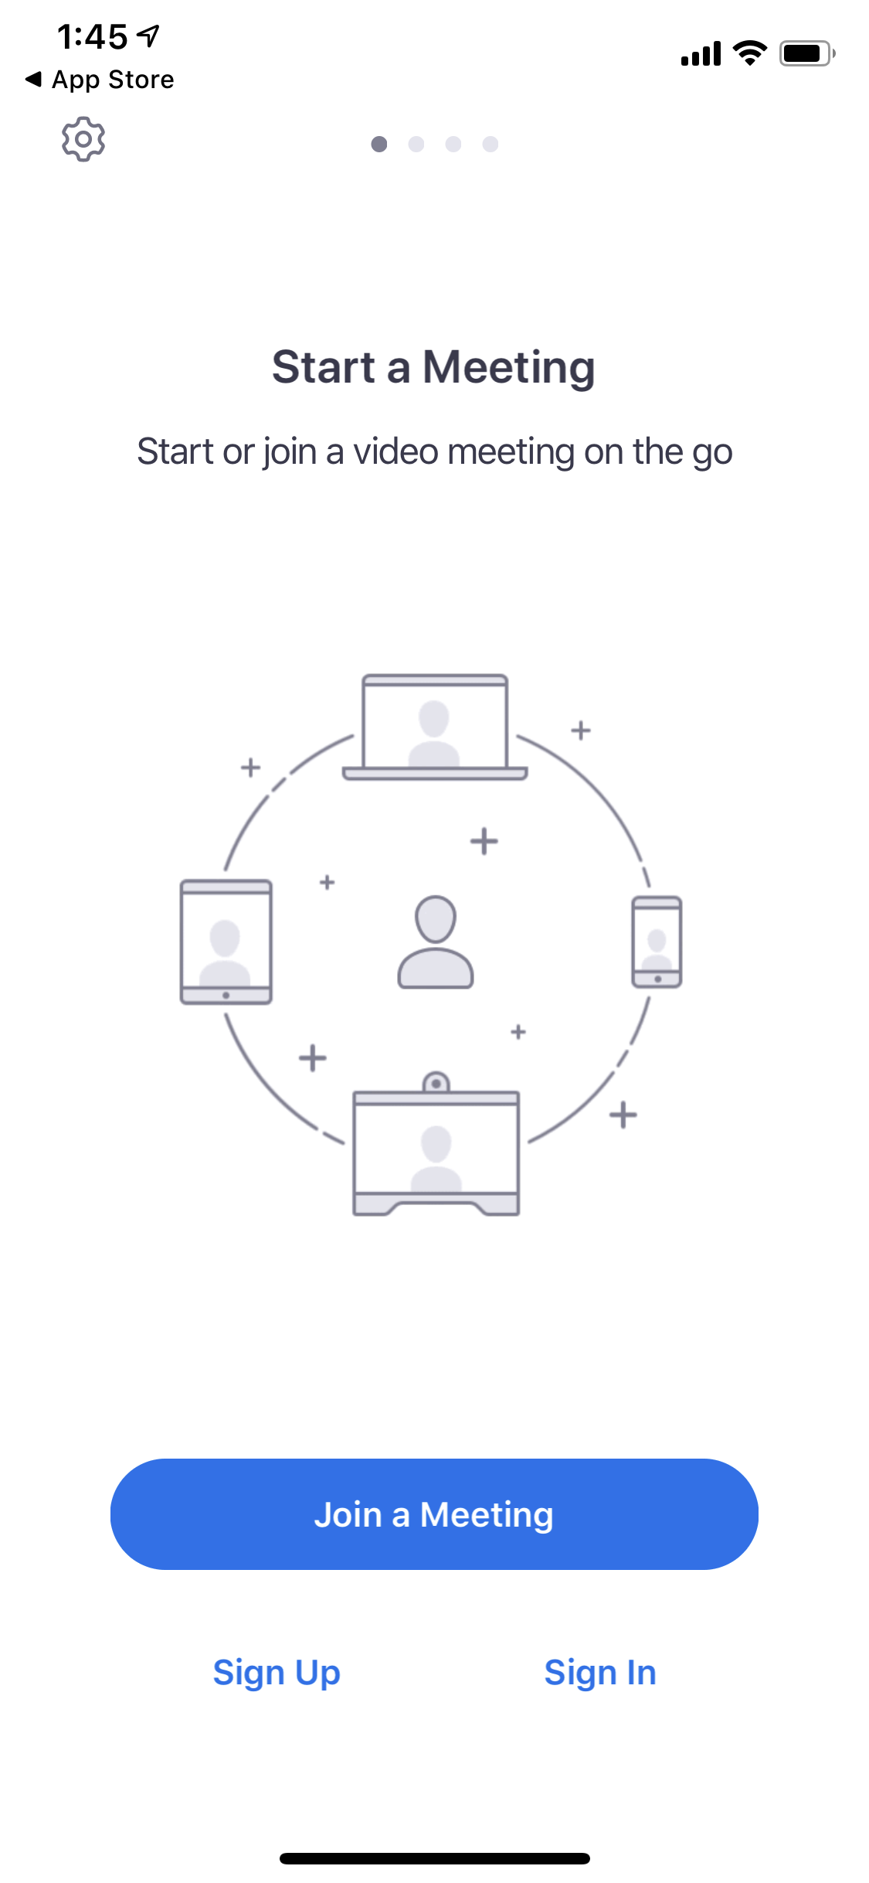Now your app is open onto Step 5: Join a Meeting
Please click join a meeting to open the next screen.

3
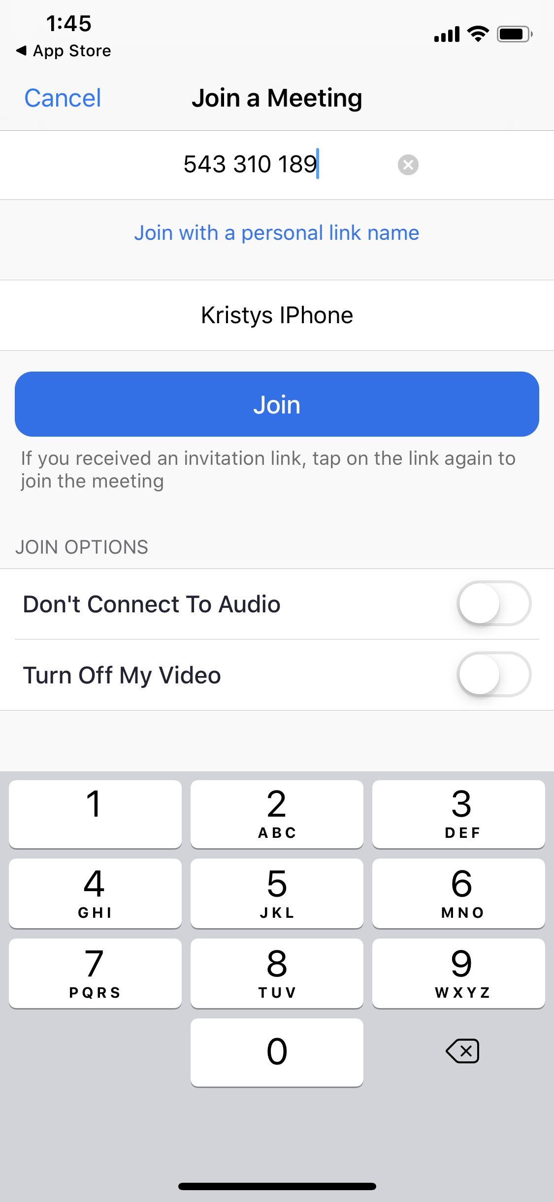Step 6: Type in Meeting Id # 568-073-9198 and click Join

Step 7: Click ok to allow zoom to access the camera (this allows everyone to see your friendly faces!
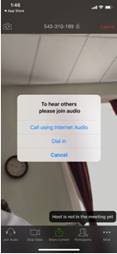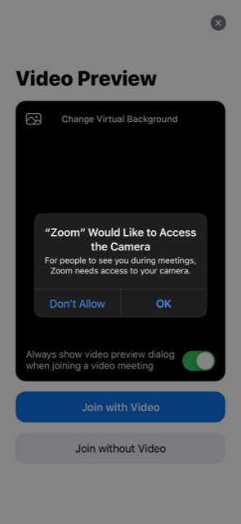 Step 8: Click call using internet audio
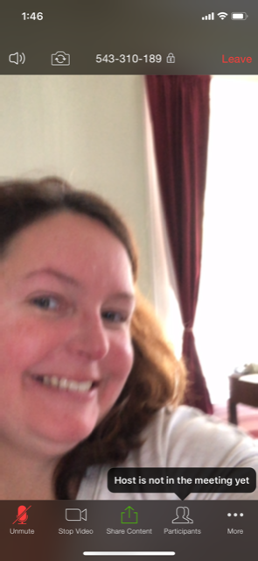

(Your screen should be a picture of you)You are now part of the Zoom Worship Service! Sit back and listen to the amazing message from Rev. Dr. Sue Pizor Yoder!

PHONE USERS:
Dial: (253) 215-8782 or
(301) 715-8592
Then enter meeting ID (when prompted): 543-310-189
Then press *6 to mute yourself (it causes too much background noise if you don’t))

You will not have video but you will be able to hear the service.
4
To join us on Facebook live:
Follow instructions previously on computer to get onto internet. In browser type: https://www.facebook.com/united.pres/
At 10:30(or a few mins after) you will see a live video begin if you are on the page. It will be the Worship Service for that week.

A Few points for you to remember: Limit the number of devices on the same service in your home (please share if possible) it helps with streaming the videos. Everyone is muted upon joining to prevent background noise. Sue & Kristy can unmute you if needed, just wave your hand on the screen for us to see you. Close all other open tabs also to help with bandwidth. And if you have any questions on how to install, how to join, etc. please call Kristy at 570-622-1760, she has the office phone rolled to answer on her cell phone. (if you leave a message it will also get to her).

5

